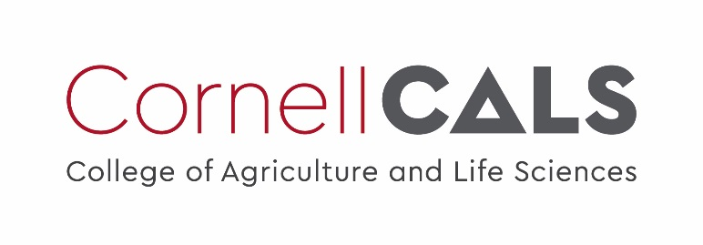

Plant Disease Diagnostic Clinic
Plant Pathology and Plant-Microbe Biology Section
329 Plant Science Building Ithaca, NY 14853‐5904

Septoria Leaf Spot of Hemp

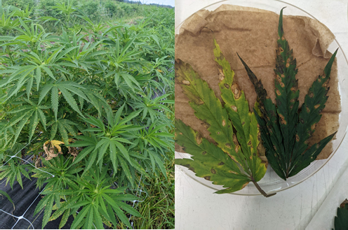
Introduction
Figure 1: Affected leaves in the inner and lower canopy. Yellow halos form around the brown lesions until they coalesce.
Septoria leaf spot of field-grown hemp is caused by the ascomycetes Septoria cannabis and Septoria neocannabina. Periods of excessive rainfall and high humidity are conductive environmental conditions for the spread of the fungus, and the disease has caused excessive damage in New York State. In 2021, symptoms appeared in June and continued through September, with the highest disease severity in July and September (Zuefle, 2022). It was detected a month earlier than it was in 2020 (Zuefle, 2021).
Although S. cannabis and S. neocannabina have only been observed on hemp, they are hypothesized to jump between hosts (genetic basis undetermined) or be present in other hosts at low levels (Verkley, 2013). Multi-gene sequencing using diagnostic loci failed to accurately differentiate between the species, as their sequences did not match published accessions (Rahnama 2021).

Signs and Symptoms
Brown or black, irregular spots with yellow halos first appear on the leaves, with the first symptoms appearing on the lower leaves and inner canopy (Figures 1). Severe defoliation can occur as the halos grow in size and eventually coalesce until the infected leaves drop from the plant. As the spots mature, they develop small, black pycnidia within the lesions on the top surface of the leaves.

Pycnidia are the fruiting body of the fungus and can be seen with the naked eye, distinguishing the fungus from other diseases (Figure 2). In moist conditions, they exude a thin, white, curly, or ribbon-like spore tendril (Figure 3).
Conidia (spores) can be visualized under a confocal microscope. Conidia are pointed at the apex and can be either curved or straight (Figure 4). They typically have 3-4 septations.
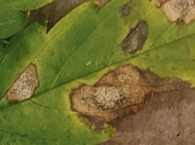
Figure 2: Mature pycnidia emerging from the lesion.

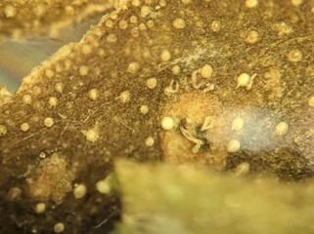
Figure 3: Spore tendrils emerging from pycnidia under moist conditions.
Figure 4: Conidia under 10x compound microscope.
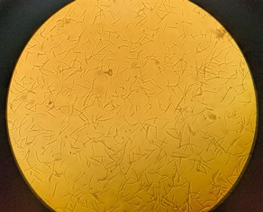

Epidemiology and Disease Cycle
Disease cycles of Septoria spp. in hemp are unknown, but it is likely that the primary infection of healthy plants originates from overwintering pycnidia in debris or from an alternative host. Conidia germinate and infect hosts through the stomata (McEno 1998). Host jumping could occur through asymptomatic tissue infection, but it is believed that Septoria spp. have narrow host ranges (Verkley 2013).
Secondary infection by Septoria occurs in moist conditions via conidia during the growing season. Conidia are both wind and water disseminated. No sexual cycle has been determined. Disease develops through the asexual life cycle and can continue to infect plants in a polycyclic manner. (Quaedvlieg, 2006).

Management Strategies
Preventative measures for Septoria include reducing humidity and allowing adequate space between plants to increase airflow. Infected leaves should be pruned off the plant and fallen leaves should be disposed of. Deep-tilling the fields in between growing seasons will aid in burying infected debris. Synthetic fungicides are not currently approved to be used on hemp in New York State, but biological products containing Bacillus spp. and Ulocladium spp. have aided in decreased fungal growth in vitro. These biological control agents have very different nontoxic mechanisms of action and may take a longer time to suppress diseases than conventional fungicides (Dixon 2022).
The USDA IR-4 project could provide more research and allow the chemical control of pathogens on hemp, which is considered a specialty crop. Currently, no commercial hemp varieties are resistant to Septoria leaf spot of hemp. A significant research effort is needed surrounding the breeding of resistant hemp varieties that are regionally adapted in addition to integrated pest management systems to control Septoria leaf spot.

1. Dixon, E., Leonberger, K., Szarka, D., Amsden, B., Smith, H., Krause, M., & Gauthier, N. (2022). Prescreening of Biological and Biorational Fungicides Against Common Hemp Pathogens Using In Vitro Analyses. Plant Health Progress, 23(3), 250–255. https://doi.org/10.1094/PHP-12-21-0143-SC
2. Barnett, H. L., & Hunter, B. B. (1972). Illustrated genera of imperfect fungi. Illustrated genera of imperfect fungi., (3rd ed).
3. Lyu, D., Backer, R., Robinson, W. G., & Smith, D. L. (2019). Plant growth-promoting rhizobacteria for cannabis production: yield, cannabinoid profile and disease resistance. Frontiers in microbiology, 1761.
4. McEno, J. (1998). Cannabis ecology. AMRITA Press. https://scholar.google.com/scholar_lookup?title=Cannabis+ecology&author=McEno%2 C+John.&publication_year=1998
5. McPartland, J. M., Clarke, R. C., & Watson, D. P. (2000). Hemp diseases and pests: management and biological control: an advanced treatise. CABI.
6. Rahnama, M., Szarka, D., Li, H., Dixon, E., Castlebury, L., & Ward Gauthier, N. A. (2021). Reemergence of Septoria Leaf Spot Caused by Septoria cannabis on Hemp in Kentucky. Plant Disease, 105(9), 2286–2289. https://doi.org/10.1094/PDIS-12-20-2620-SC
7. Quaedvlieg, W. G. J. M., Verkley, G. J. M., Shin, H. D., Barreto, R. W., Alfenas, A. C., Swart, W. J., ... & Crous, P. W. (2006). Sizing up septoria. Studies in mycology, 55(1), vi-vi.
8. Verkley, G. J. M., Quaedvlieg, W., Shin, H.-D., & Crous, P. W. (2013). A new approach to species delimitation in Septoria. Studies in Mycology, 75(1), 213–305. https://doi.org/10.3114/sim0018
9. Zuefle, M.E. 2022. Hemp Pest Survey 2021. NYS IPM project report. August 9, 2021. Web
10. Zuefle, M.E. 2021. Hemp Pest Survey 2020. NYS IPM project report. August 9, 2021. Web.

Prepared by Jocelyn Schwartz, December 2022
READ THE LABEL BEFORE APPLYING ANY PESTICIDE! Changes in pesticide regulations occur constantly. All pesticides distributed, sold, and/or applied in New York State must be registered with the New York State Department of Environmental Conservation (DEC). Questions concerning the legality and/or registration status for pesticide use in New York State should be directed to the appropriate Cornell Cooperative Extension Specialist or your regional DEC office.
The Cornell Plant Disease Diagnostic Clinic
Phone: 607‐255‐7850
Fax: 607‐255‐4471
Email: mailto:Cornell-plantdiseaseclinic@cornell.edu
Web: plantclinic.cornell.edu

